**ASSIGNMENT 1**

**EM 314 – NUMERICAL METHODS**

LIYANAGE D.P

E/15/202

**QUESTION 01**

$$\sin\left(x\right)= \sum_{n=0}^{∞}{\frac{{(-1)}^{n}}{\left(2n+1\right)!}}x^{2n+1} + E_{n}(x)$$

$$E_{n}\left(x\right)={(-1)}^{2n+3}\frac{x^{2n+3}}{\left(2n+3\right)!}$$

Therefore error occurs in using Taylor’s series for sin(x) = ${(-1)}^{2n+3}\frac{x^{2n+3}}{\left(2n+3\right)!}$

Error for sin(x) ≈ x ⇒ ${(-1)}^{2n+3}\frac{x^{2n+3}}{\left(2n+3\right)!}$

To become this approximation to be accurate within 10-6

**QUESTION 02**

Number of digits that can be possessed by the number just after the floating point is β-1 (because it can have only numbers from 1 to β-1)

But the other numbers after that number can have numbers from 0 to β-1

So the number of elements it can have is β

Mantissa has t numbers

So the number of different ways that we can keep the numbers from 0 to β-1 in t-1 places is = βt - 1

Therefore the total number of different mantissas is = (β-1) X βt - 1

Here the upper bound is U and the lower bound is L

So the different numbers that the exponent can have is U – L + 1

Number of different positive or negative floating point numbers = (β-1) βt – 1(U – L + 1)

Therefore number of elements in the set **F** is = 2(β-1) βt – 1(U – L + 1)

**QUESTION 03**

$f(x+h)$ = $f(x)$ + $f^{\left(1\right)}\left(x\right)h$ + $\frac{f^{\left(2\right)}(x)}{2!}h^{2}$

$$\frac{f\left(x+h\right)-f(x)}{h}= f^{\left(1\right)}\left(x\right)+ \frac{f^{\left(2\right)}(x)}{2!}h$$

$$f_{h}^{\left(1\right)}\left(x\right)=f^{\left(1\right)}\left(x\right)+ \frac{f^{\left(2\right)}(x)}{2!}h$$

$$f^{\left(1\right)}\left(x\right)- f_{h}^{\left(1\right)}\left(x\right)= -\frac{f^{\left(2\right)}(x)}{2!}h$$

$$\left|{ f}^{\left(1\right)}\left(x\right)- f_{h}^{\left(1\right)}\left(x\right) \right|=\left|\frac{f^{\left(2\right)}\left(x\right)}{2!}h\right| Ch$$

We can find a constant C such that $\left|{ f}^{\left(1\right)}\left(x\right)- f_{h}^{\left(1\right)}\left(x\right) \right|$ $Ch$ when x ≥ k

Therefore $E_{h}\left(x\right)= (h)$

**QUESTION 04**

%(a)

A = magic(500);

ta1=cputime();

a = det(A)

ta2 = cputime();

B = magic(1000);

tb1 = cputime();

b = det(B)

tb2 = cputime();

C = magic(1500);

tc1 = cputime();

c = det(C)

tc2 = cputime();

D = magic(2000);

td1 = cputime();

d = det(D)

td2 = cputime();

E = magic(2500);

te1 = cputime();

e = det(E)

te2 = cputime();

F = magic(3000);

tf1 = cputime();

f = det(F)

tf2 = cputime();

G = magic(3500);

tg1 = cputime();

g = det(G)

tg2 = cputime();

H = magic(4000);

th1 = cputime();

h = det(H)

th2 = cputime();

I = magic(4500);

ti1 = cputime();

i = det(I)

ti2 = cputime();

J = magic(5000);

tj1 = cputime();

j = det(J)

tj2 = cputime();

%(c)

X = [500 1000 1500 2000 2500 3000 3500 4000 4500 5000]

Y = [ta2-ta1 tb2-tb1 tc2-tc1 td2-td1 te2-te1 tf2-tf1 tg2-tg1 th2-th1 ti2-ti1 tj2-tj1]

loglog(X,Y,'o');

hold on

%(d)

p = polyfit(log(X),log(Y),1);

p1 = polyval(p,log(X));

loglog(X,exp(p1),'-')

legend('Without polyfit','With polyfit')

hold off

**Solution**

a = 0

b = 0

c = 0

d = 0

e = 0

f = 0

g = 0

h = 0

i = 0

j = 0

X = 500 1000 1500 2000 2500 3000 3500 4000 4500 5000

Y = 0.0156 0.0313 0.1250 0.2188 0.4375 0.7813 1.2031 1.7813 2.4063 3.3906

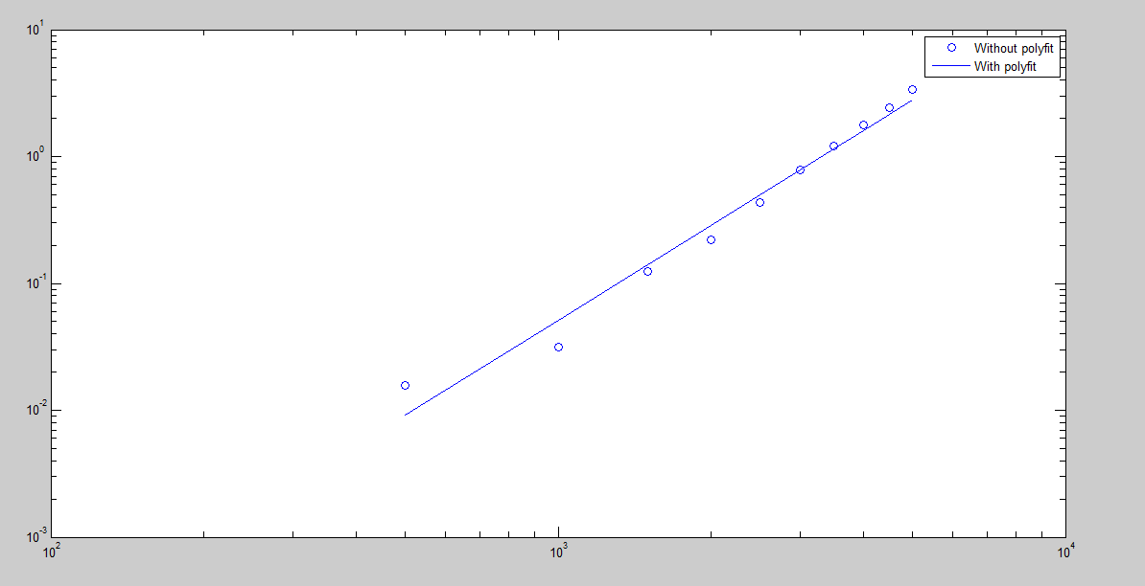

(e) 0.0313 α 1000α ⎯⎯⎯⎯ (1)

3.3906 α 5000α ⎯⎯⎯⎯ (2)

(1)/(2) ⇒ 0.0313 /3.3906 = 0.2α

ln(0.0313 /3.3906 ) = αln(0.2)

α = ln(0.0313 /3.3906 ) / ln(0.2)

α = 2.91

(f) det(A) = a < 5003

det(B) = b < 10003

det(C) = c < 15003

det(D) = d < 20003

det(E) = e < 25003

det(F) = f < 30003

det(G) = g < 35003

det(H) = h < 40003

det(I) = i < 45003

det(J) = j < 50003

Therefore computer results and theoretical results are same

**QUESTION 05**

(a) K = [1:1:10]

H = 1/2.*(1/2).^(0:9)

x = 3;

F = 1./H.*(log(x+H) - log(x))

E = abs(1/x - F)

loglog(H,E)

grid on

**Solution**

|  |  |  |  |
| --- | --- | --- | --- |
| ***k*** | $$h_{k}$$ | $$f_{h_{k}}^{}(x)$$ | $$E_{h_{k}}$$ |
| 1 | 0.5000 | 0.3083 | 0.0250 |
| 2 | 0.2500 | 0.3202 | 0.0132 |
| 3 | 0.1250 | 0.3266 | 0.0068 |
| 4 | 0.0625 | 0.3299 | 0.0034 |
| 5 | 0.0313 | 0.3316 | 0.0017 |
| 6 | 0.0156 | 0.3325 | 0.0009 |
| 7 | 0.0078 | 0.3329 | 0.0004 |
| 8 | 0.0039 | 0.3331 | 0.0002 |
| 9 | 0.0020 | 0.3332 | 0.0001 |
| 10 | 0.0010 | 0.3333 | 0.0001 |

(b) 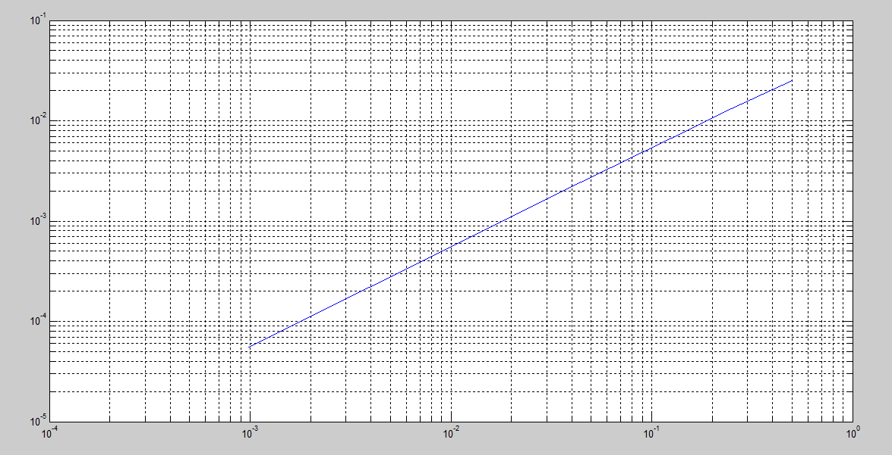

0.025 α 0.5γ ⎯⎯⎯⎯ (1)

0.0132 α 0.25γ ⎯⎯⎯ (2)

(1)/(2) ⇒ 0.025/0.0132 = (0.5/0.25)γ

ln(0.025/0.0132) = γln(0.5/0.25)

γ = 0.92

According to the value table we can say that every Eh value is always less than h values when

h ≥ 0.5

Therefore it satisfy Eh = Ο(h)

(c) K = [1:1:40]

H = 1/2.*(1/2).^(0:39)

x = 3;

F = 1./H.*(log(x+H) - log(x))

E = abs(1/x - F)

loglog(H,E)

grid on

**Solution**

|  |  |  |  |
| --- | --- | --- | --- |
| ***k*** | $$h_{k}$$ | $$f_{h_{k}}^{}(x)$$ | $$E_{h_{k}}$$ |
| 1 | 0.5000 | 0.3083 | 0.0250 |
| 2 | 0.2500 | 0.3202 | 0.0132 |
| 3 | 0.1250 | 0.3266 | 0.0068 |
| 4 | 0.0625 | 0.3299 | 0.0034 |
| 5 | 0.0313 | 0.3316 | 0.0017 |
| 6 | 0.0156 | 0.3325 | 0.0009 |
| 7 | 0.0078 | 0.3329 | 0.0004 |
| 8 | 0.0039 | 0.3331 | 0.0002 |
| 9 | 0.0020 | 0.3332 | 0.0001 |
| 10 | 0.0010 | 0.3333 | 0.0001 |
| 11 | 0.0005 | 0.3333 | 0.0000 |
| 12 | 0.0002 | 0.3333 | 0.0000 |
| 13 | 0.0001 | 0.3333 | 0.0000 |
| 14 | 0.0001 | 0.3333 | 0.0000 |
| 15 | 0.0000 | 0.3333 | 0.0000 |
| 16 | 0.0000 | 0.3333 | 0.0000 |
| 17 | 0.0000 | 0.3333 | 0.0000 |
| 18 | 0.0000 | 0.3333 | 0.0000 |
| 19 | 0.0000 | 0.3333 | 0.0000 |
| 20 | 0.0000 | 0.3333 | 0.0000 |
| 21 | 0.0000 | 0.3333 | 0.0000 |
| 22 | 0.0000 | 0.3333 | 0.0000 |
| 23 | 0.0000 | 0.3333 | 0.0000 |
| 24 | 0.0000 | 0.3333 | 0.0000 |
| 25 | 0.0000 | 0.3333 | 0.0000 |
| 26 | 0.0000 | 0.3333 | 0.0000 |
| 27 | 0.0000 | 0.3333 | 0.0000 |
| 28 | 0.0000 | 0.3333 | 0.0000 |
| 29 | 0.0000 | 0.3333 | 0.0000 |
| 30 | 0.0000 | 0.3333 | 0.0000 |
| 31 | 0.0000 | 0.3333 | 0.0000 |
| 32 | 0.0000 | 0.3333 | 0.0000 |
| 33 | 0.0000 | 0.3333 | 0.0000 |
| 34 | 0.0000 | 0.3333 | 0.0000 |
| 35 | 0.0000 | 0.3333 | 0.0000 |
| 36 | 0.0000 | 0.3333 | 0.0000 |
| 37 | 0.0000 | 0.3333 | 0.0000 |
| 38 | 0.0000 | 0.3334 | 0.0000 |
| 39 | 0.0000 | 0.3334 | 0.0000 |
| 40 | 0.0000 | 0.3335 | 0.0002 |

(d) As you can see in the table $f_{h_{k}}^{}(x)$ increases after 37. That means the derivative of ln(x) shows a minimum value as it is the graph of a x-1

Therefore the according to the equation of error, the associated error will starts to increase after the minimum value.

This happens because we are doing this in a computer. There are limitations for computer arithmetic. But if we do this manually the value will decrease.

(e) 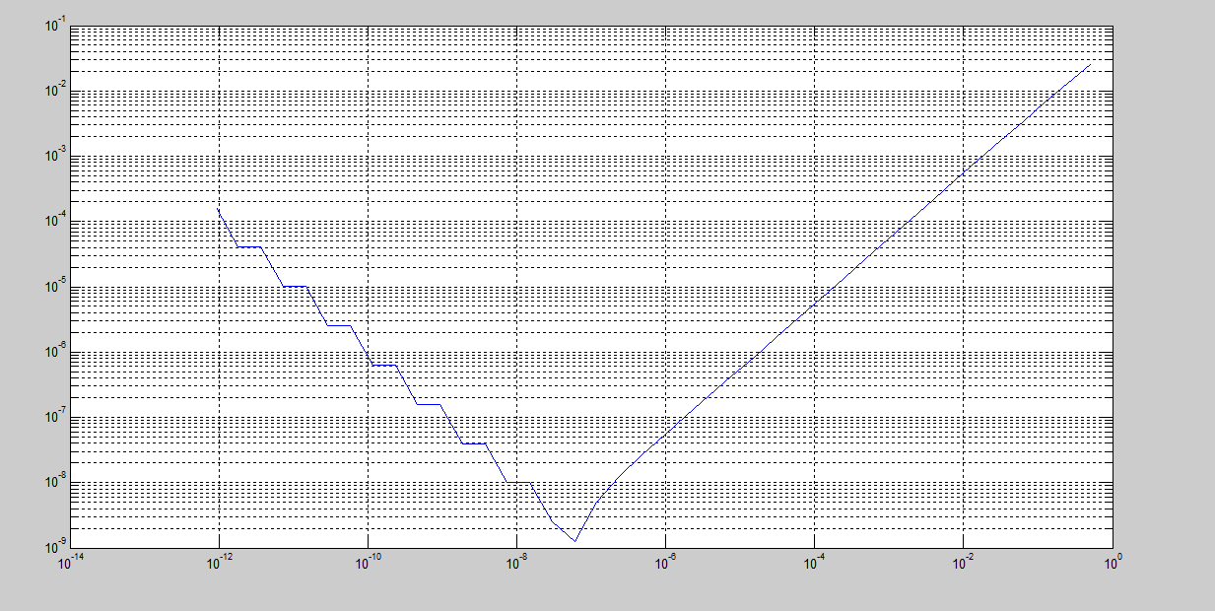

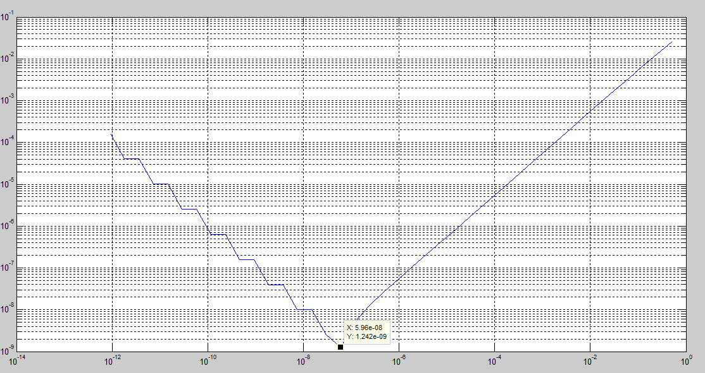

ln(hmin) = 5.96*10-8

hmin = = 1